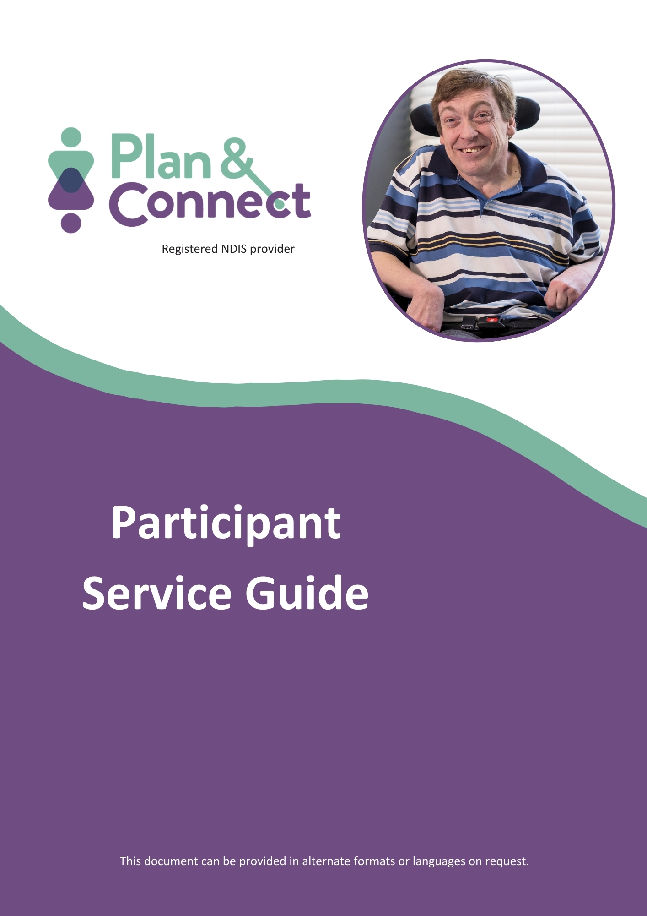
March 2026
Introduction
What is this guide for?
This guide provides information for NDIS participants about Plan & Connect, the services we provide and how we provide them.

Who is Plan & Connect?
Plan & Connect is a business arm of Regional Disability Advocacy Service Ltd (RDAS). Plan & Connect was set up to provide the following services through the National Disability Insurance Scheme (NDIS):
- Support Coordination
- Plan Management

Plan & Connect is a registered NDIS provider.
We employ staff to provide local, independent and professional services. We do not offer any direct services and are therefore well placed to understand the specific needs of people with disability in regional areas, and to source providers that best suit our Participants’ needs.
Plan & Connect will work with you to find the right supports to help you become more independent at home and in the community. We will also help you to have choice and control over your NDIS plan.

Statement of Welcome and Inclusion

Our service welcomes Aboriginal and Torres Strait Islander people and acknowledge that they are the traditional custodians of the land. Our service is also committed to providing a safe and inclusive workplace and services for people of LGBTIQ+ communities and their families.
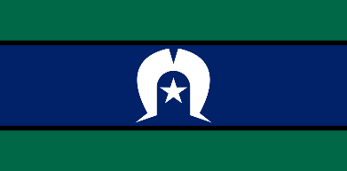


Who can use Plan & Connect?

We can only work with NDIS participants who:
- Have funding allocated in their plans for either Support Coordination or Plan Management or both, AND
- Live in North-Eastern Victoria or Southern New South Wales

What does Plan & Connect NOT do?

We cannot help with the following:
- Counselling
- Legal, financial or medical advice
- Case management
- Crisis intervention
- Mediation

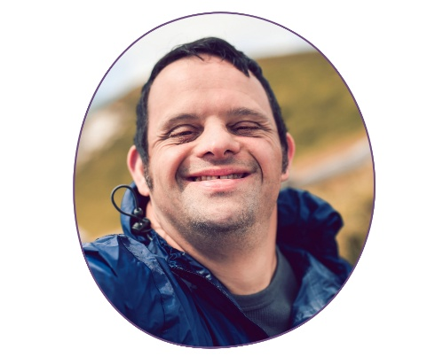
Our Services
Plan & Connect provides the following services through the National Disability Insurance Scheme (NDIS):
- Support Coordination
- Plan Management

It is important to note that Participants are under no obligation to engage Plan & Connect or both Support Coordination and Plan Management. You are entirely free to come to us for just one service, or the other, or both.

Support Coordination
Support Coordination provides ongoing assistance to strengthen your ability to design and build your own disability support system. Our Support Coordinators will help you to find providers who best suit your unique needs, and will work to ensure your providers are delivering an appropriate service within the scope of your NDIS funding.
Our Support Coordinators are also experienced at identifying and managing upcoming risks, such as major life changes (for example, leaving school, moving house or requiring new carers), and are committed to putting your needs first.

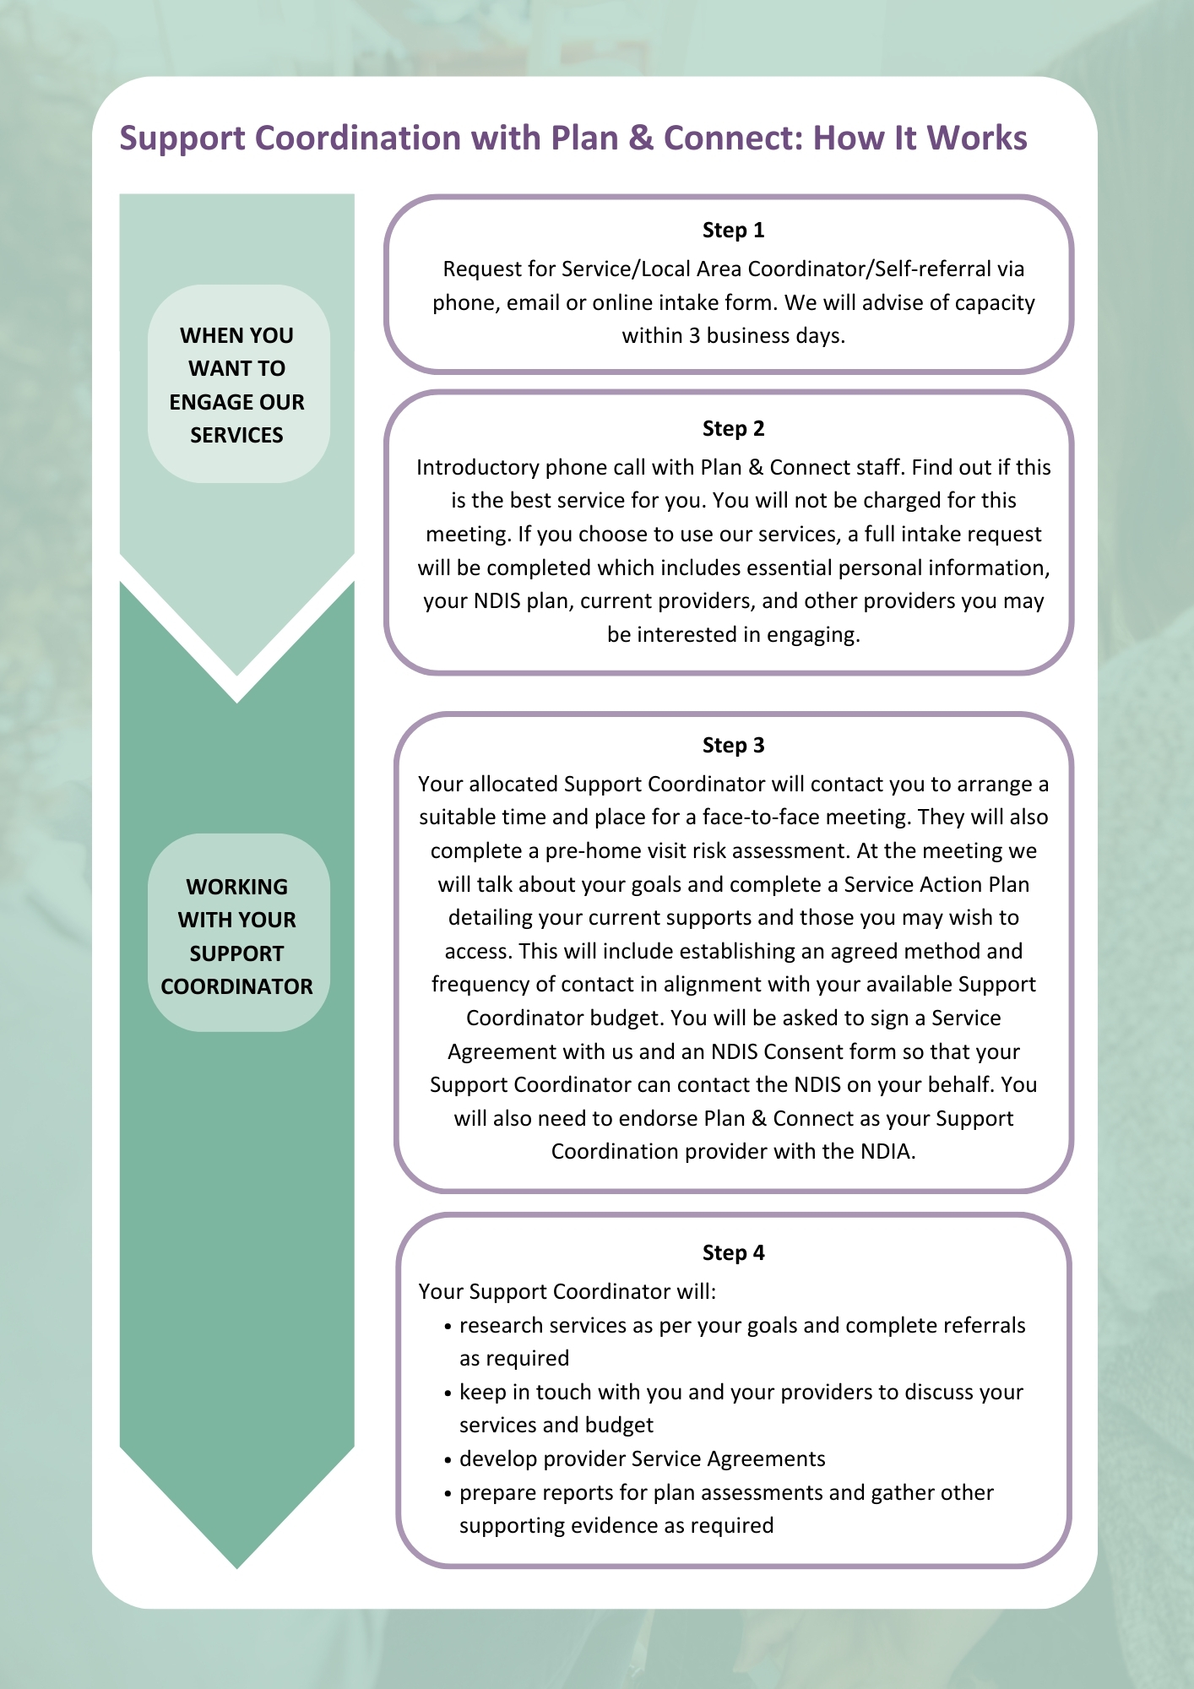
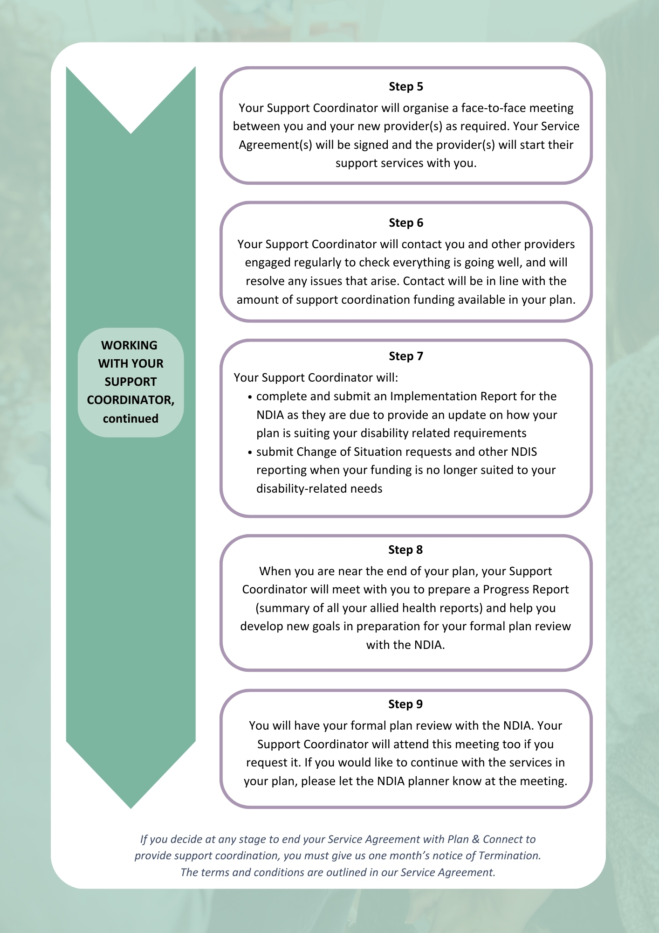
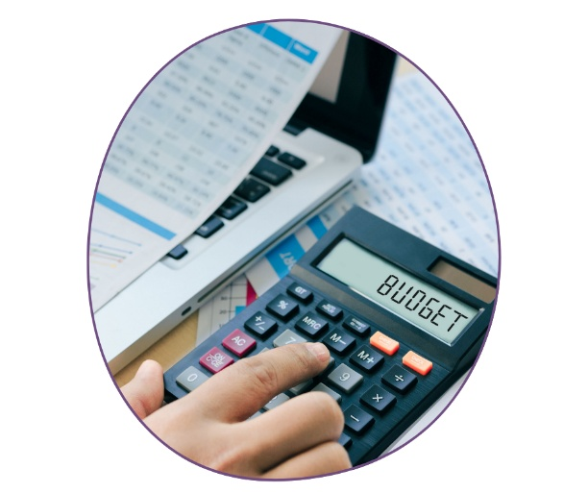
Plan Management
This service provides financial administration of your NDIS plan. It includes:
- Increasing your control over how your plan is put into practice and used
- Managing and monitoring your budgets over the course of your plan
- Managing NDIS claims and paying Providers for delivered services
- Maintaining records and producing regular statements which show how much funding is left in your plan
- Providing advice on the Terms and Conditions of any of your Provider Service Agreements, and quarantining funds allocated within those Service Agreements
- Providing access to a wider range of service providers, including non-registered providers, while remaining in line with the NDIS price guide for your services

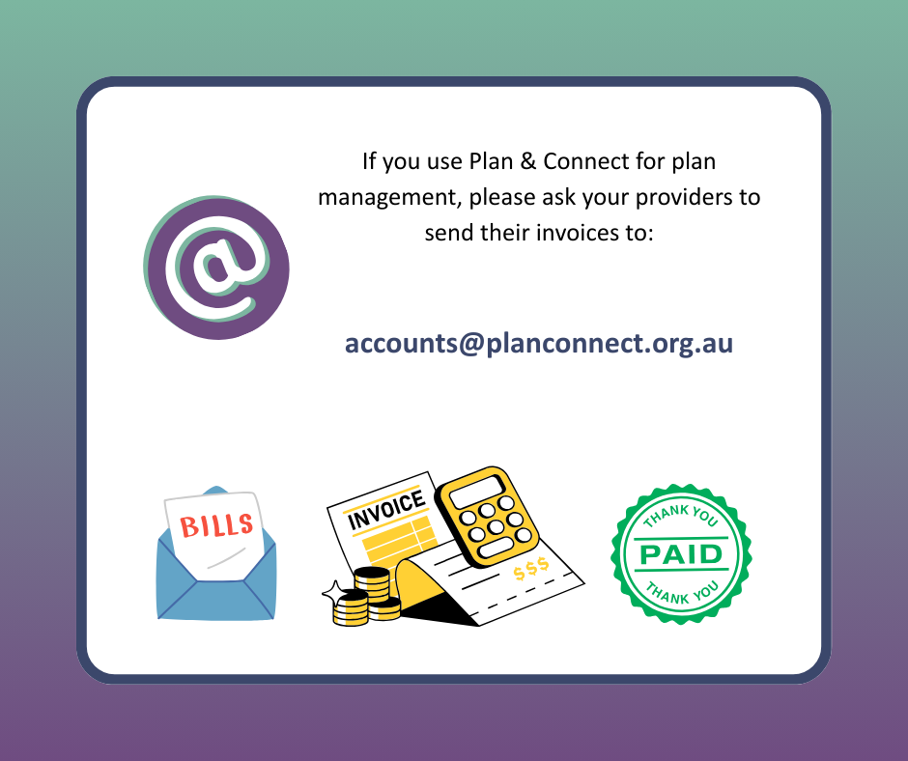
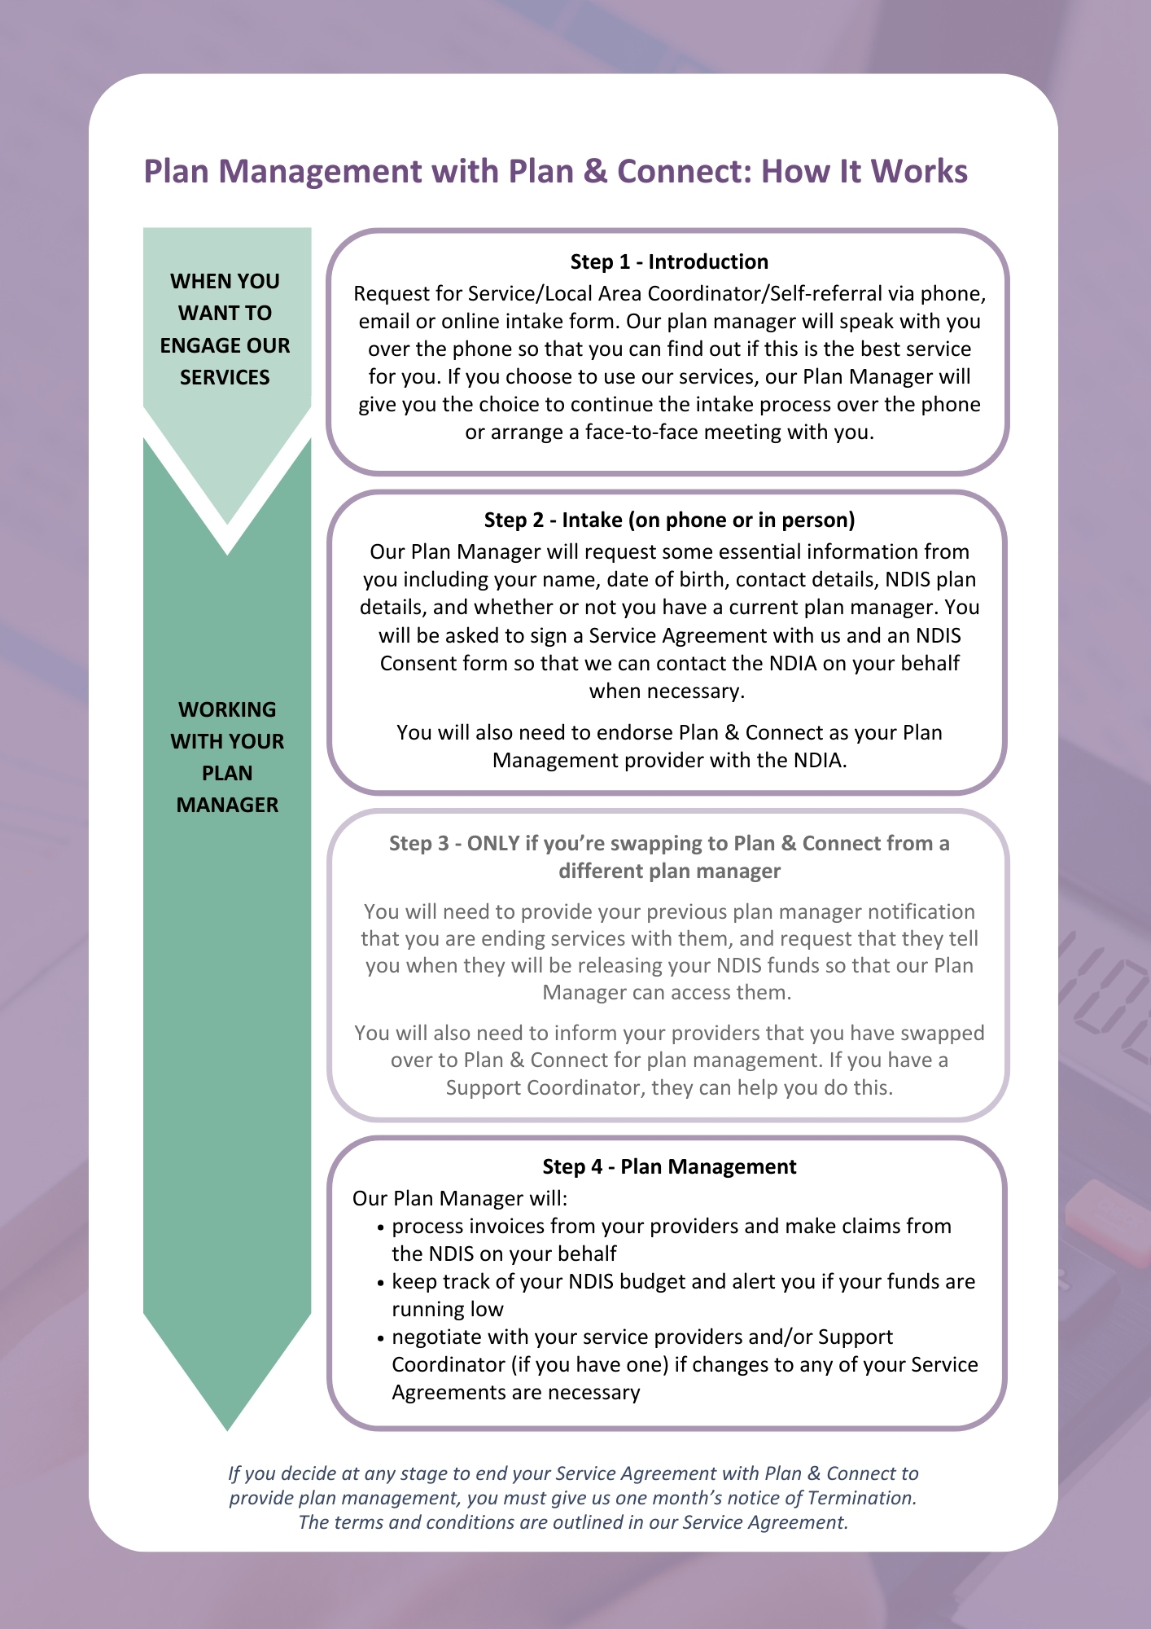

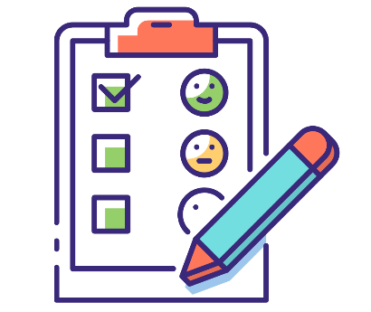
Participant Surveys
As part of our ongoing commitment to continuous service improvement, Plan & Connect conducts random surveys with participants and nominees over the phone.
You may receive a call from someone from Plan & Connect who will introduce themselves and ask for feedback about your experience with our Plan Management or Support Coordination service.
The survey is brief with under 10 questions. You will be asked whether you feel well supported by your plan manager/support coordinator; how accessible and responsive they are and whether you would like to comment on the service you are receiving.
Feedback is shared with the relevant Plan & Connect employee and Management. When feedback is less than positive or raises any concerns the Manager will contact you for additional comments and we will address concerns raised.
Your feedback is always welcome and we appreciate any comments on our service and suggestions on how we can improve.
Should you wish to provide feedback at any time, we welcome your comments. Refer to Page 15 in this guide for further information about providing feedback.


Other Important Information
Your Rights and Responsibilities
Plan & Connect strives to make sure that every person’s human rights are protected. We use the Universal Declaration of Human Rights to guide our practice.
You have the right to:
- Be treated with respect
- Have your privacy and dignity upheld by us
- Access our services without discrimination based on your gender, sexuality, race, culture, or religion
- Be informed about available supports
- Choose from available alternatives
- Make a complaint without fear of payback
- Receive copies of Plan & Connect’s Policies and Procedures on request
- Have any service information made available to you in appropriate language or an alternative format
- Receive a service free of conflict of interest

You have the responsibility to:
- Provide the correct information needed for Plan & Connect to provide services to you
- Let us know if your plan has changed
- Let us know if you are unable to keep an appointment
- Behave in a manner that promotes respect and dignity



Any person who acts in a threatening manner will have it brought to their attention and be requested to modify their behaviour. If threatening behaviour continues, the person will be asked to leave and Plan & Connect’s services may be withdrawn.

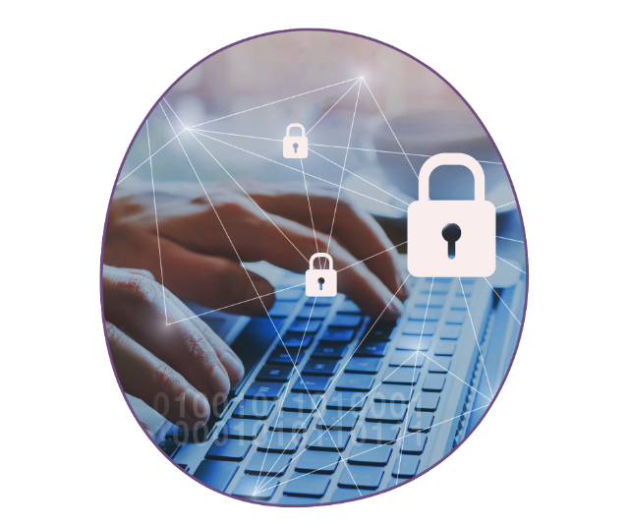
Privacy, Dignity and Confidentiality
Plan & Connect respects your right to privacy, dignity and confidentiality. We have policies and procedures that protect the confidentiality of any personal infomration you share. Our privacy policy can be provided at your request.

How we keep your information private
Plan & Connect keeps electronic, password-protected records of personal details such as your age, address and phone number, disability, Aboriginality, cultural diversity, sexuality and where you were born. This information is used to provide you with culturally appropriate support. We are also required to create reports on this information for our Government funding. However, these reports are created in such a way that your information cannot be identified directly with you.
If we need to contact a third party to discuss your information, we must have your permission to do so first.
Plan & Connect will keep your information in a locked filing cabinet or on a computer system with passwords. The only people who will be able to see your information are people who already have permission to access it.

You can access your own records
You have the right to see the information on your file. A request for access may take up to 21 days to be actioned.

Sharing your information with certain third parties
Plan & Connect will need to share your information without your permission only if:
- The law says we have to disclose it
- Your life or someone else’s life is in danger
- The information is needed for court or legal proceedings.

If you think your privacy has been breached
If you believe we have not appropriately followed our privacy policy, you can make an appointment with the Executive Officer of RDAS.
If the issue cannot be resolved through RDAS, you can take your complaint to the NDIS. You can find more information about how to do this on page 12.

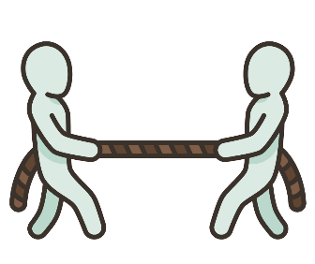
Conflict of Interest
Plan & Connect is owned by Regional Disability Advocacy Service (RDAS), which provides free advocacy support to anyone with a disability, including NDIS participants.
If a client of RDAS ever has an issue concerning Plan & Connect, this could lead to a real or perceived conflict of interest for our Advocates.
A conflict of interest is when someone is in a situation that could make it hard for them to make a fair decision because their own benefit might get in the way of doing what’s best for others
RDAS has developed an Advocacy, Support Coordination and Plan Management Conflicts of Interest Management Statement to explain how a client will be supported in this situation.
This statement is publicly displayed in each RDAS office and is also available via the RDAS website here: https://rdas.org.au/wpcontent/uploads/2024/05/ Advocacy-Support-Coordination-PM-Conflict-of-Interest-Statement.pdf.

NDIS Practice Standards
Plan & Connect is a registered NDIS service provider, with NDIS registration number 4050033747. This means we have several requirements that must be met in order to maintain our registration with the NDIS Commission. We are also subject to conditions and rules under the NDIS Act, and must comply with the NDIS Practice Standards. These Standards specify the quality of supports and services that must be provided to NDIS Participants. Together with the NDIS Code of Conduct, the Standards build Participants’ awareness of what quality service provision they can expect from registered providers.

Incident Management and Mandatory Reporting of Reportable Incidents
Incident Management
As a registered NDIS provider, Plan & Connect is required to have an incident management system and to report some acts (or alleged acts) relating to serious harm or unauthorized restrictive practices to the NDIA Quality and Safeguards commission. Incidents are recorded, investigated and where necessary, corrective action is taken.
Registered NDIS providers must report specific incidents to the NDIS Commission to ensure the safety and well-being of participants, with strict timeframes for reporting.

What is Mandatory Reporting?
Mandatory reporting is essential for safeguarding the rights and dignity of NDIS participant. Mandatory reporting under the NDIS is a critical requirement aimed at protecting participants. Registered NDIS providers areobligated to report incidents that pose risks to participants' health, safety, or well-being. This includes both substantiated incidents and allegations, fostering a culture of vigilance and proactive intervention. Consent is not required when reporting concerns.
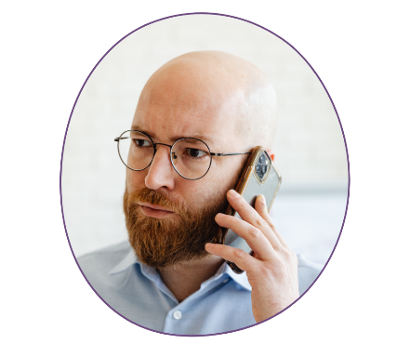
A reportable incident is defined as any act or event that occurs in connection with the delivery of NDIS supports or services that has, or has the potential to cause, harm to a participant. Key types of reportable incidents include:
- Death of a person with a disability
- Serious injury of a person with a disability
- Abuse or neglect of a person with a disability
- Unlawful sexual or physical contact with, or assault of, a person with a disability
- Sexual misconduct against, or in the presence of, a person with a disability
- Use of unauthorized restrictive practices

Registered NDIS Providers MUST notify the NDIS Commission of all reportable incidents within specified timeframes:
- Within 24 hours for incidents that result in harm to a participant
- Within five business days for other reportable incidents
Failure to report incidents within these timeframes can lead to compliance actions, including infringement notices or other regulatory measures.

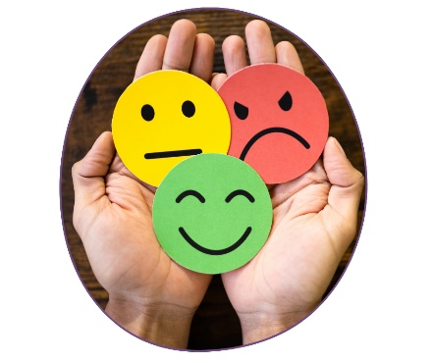
Do you have a complaint, a compliment, or want to provide feedback?
Plan & Connect respects the right of every participant to make a complaint, provide a compliment, or to simply provide feedback about the service they have received.
You will not be treated differently or refused service if you make a complaint.

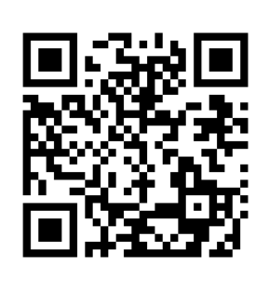
How to provide feedback to Plan & Connect
Online feedback form
Go to https://planconnect.org.au/contact/#message-us or scan this QR code.
Phone
Call 1300 886 388 and press option 1.
Post
Send a letter marked “Private and Confidential” to:
Plan & Connect
PO Box 982
Wodonga VIC 3689
Your feedback or complaint will be directed to the person who is best able to respond or take further action.

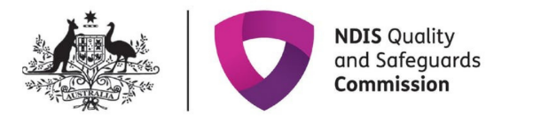
IMPORTANT

You are welcome to make an external complaint if you are not happy with the way Plan & Connect has dealt with your issue, or if you don’t feel comfortable contacting us directly. Call the NDIS Quality & Safeguards Commission on 1800 035 544, or visit www.ndiscommision.gov.au/about/making-complaint.

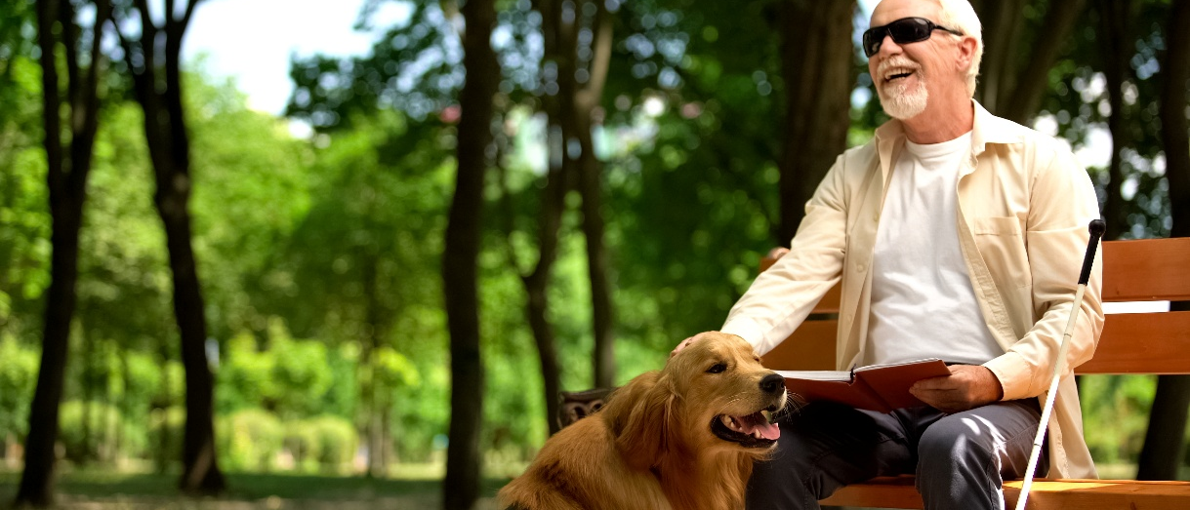

Other Ways to Contact Plan & Connect
In addition to the ways listed on the previous page, you can also get in touch via:
Email: admin@planconnect.org.au
Web: www.planconnect.org.au
Office: 132 Melbourne Rd, Wodonga VIC 3690
Our Wodonga office is open from 9am to 5pm, Monday to Friday and you can drop in any time.
Our phone line is open from 9am to 4pm, Monday to Friday. If you are calling out of hours, please leave a message and we will get back to you as soon as possible.
Our Wangaratta office is available for meetings by appointment only.

It’s OK to talk about abuse and neglect

The National Disability Abuse and Neglect Hotline is a free, independent and confidential service for reporting mistreatment of people with disability. Anyone can contact the hotline: family members, friends, service providers or a person with disability.
To make a report, contact the hotline on 1800 880 052 or send an email to hotline@workfocus.com.
The hotline is not a crisis service. In case of life-threatening situations call 000 for attendance by Ambulance, Fire or Police services. If you think a crime has been committed or is being committed, contact your local police.

Would you like to become a member of Regional Disability Advocacy Service?
By becoming a member of RDAS you can demonstrate your support for an organisation that advocates for the rights of people with disability.

What does membership give me?
As a member of RDAS you will:
- Receive an invitation to the RDAS Annual General Meeting
- Have a say in how RDAS is run
- Receive The Advocate, RDAS’ quarterly community newsletter, as well as invitations to community forums and consultations
- Be counted as one of the many individuals who support the rights of people with disability in our community

Who can be a member?
- Persons with disability
- Carers/family members of persons with disability
- Individuals who support RDAS’ vision, mission, values and purpose
- People who live, work or study in RDAS’ service regions of North East Victoria or Southern Riverina New South Wales, or who have an association with these regions.

Membership and subscription to the newsletter is FREE.
Contact RDAS on 1800 250 292 or scan this QR code to sign up.

